Міністерство освіти і науки України

Національний технічний університет України «Київський політехнічний

інститут імені Ігоря Сікорського"

Факультет інформатики та обчислювальної техніки

Кафедра інформатики та програмної інженерії

Звіт

з лабораторної роботи № 2 з дисципліни

«Основи програмування 2. Модульне програмування»

Варіант 25

Виконав студент ІП-14 Радзівіло Валерія Артемівна

(шифр, прізвище, ім'я, по батькові)

Перевірив

( прізвище, ім'я, по батькові)

Київ 2022

**Лабораторна робота №2**

**Тема роботи:** Бінарні файли

**Мета роботи:** Вивчити особливості створення й обробки бінарних файлів даних.

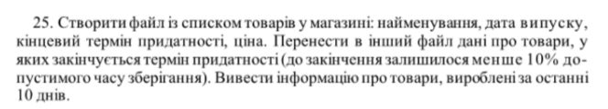

**Вирішення задачі С++:**

**main:**

#include<iostream>  
#include<fstream>  
#include <ctime>  
#include "header.cpp"  
using namespace std;  
  
  
int main() {  
 int work = 0;  
  
 do {  
 time_t ttime = time(0);  
 tm *local_time = localtime(&ttime);  
 string today = to_string(local_time->tm_mday) + ".0" + to_string(1 + local_time->tm_mon) + "." +  
 to_string(1900 + local_time->tm_year);// today's date as string  
 Pack Goods;  
 int goods_amount = 0;  
 string names[200], date_mades[200], use_till_dates[200];  
 int prices[200];  
 //get input from user  
 get_info(goods_amount, names, date_mades, use_till_dates, prices);  
 //create and fill first file with product list  
 make_first_file(Goods, goods_amount, names, date_mades, use_till_dates, prices, "product_list.dat");  
 //read the file  
 read_file("product_list.dat", goods_amount);  
 //make new file according to the task  
 find_data(goods_amount, "end_of_expiration.dat", names, date_mades, use_till_dates, prices, today);  
 cout << endl;  
 // print products that were made 10 days or less ago  
 in_the_last_ten(goods_amount, names, date_mades, use_till_dates, prices, today);  
 cout << "Do you want to do the program again?(print 0 if yes)"<< endl;  
 //to re-run the program  
 cin >> work;  
 cin.ignore();  
 }while(work == 0);  
  
  
 return 0;  
}

**header.h:**

#ifndef INC_2LAB_HEADER_H  
#define INC_2LAB_HEADER_H  
#include <iostream>  
#include <fstream>  
#include <filesystem>  
#include <cstring>  
  
using namespace std;  
typedef struct Goods {  
 string name;  
 string date_made;  
 string use_till_date;  
 int price;  
}Pack;  
  
void get_info(int &goods_amount, string *prod_names,string *prod_date_mades,string *prod_use_till_dates, int *prices);  
int make_first_file(struct Goods, int goods_amount, string *prod_names,string *prod_date_mades,string *prod_use_till_dates, int *prices, string first_file);  
int date_difference(string date_one, string date_two);  
int read_file(string filename, int goods_amount);  
void find_data(int goods_amount,string second_file, string *prod_names,string *prod_date_mades,string *prod_use_till_dates, int *prices, string today);  
void in_the_last_ten(int goods_amount, string *prod_names,string *prod_date_mades,string *prod_use_till_dates, int *prices, string today);  
#endif //INC_2LAB_HEADER_H

**header.cpp:**

#include "header.h"  
void get_info(int &goods_amount, string *prod_names,string *prod_date_mades,string *prod_use_till_dates, int *prices)  
{  
 string to_end;  
  
 int i = 0;  
 do {  
 string prod_name;  
 cout << "Enter product name: ";  
 getline(cin, prod_name);  
 prod_names[i] = prod_name;  
 string prod_date_made;  
 do {  
 cout << "Enter product release date: ";  
 getline(cin, prod_date_made);  
 } while (prod_date_made.length() != 10);  
 prod_date_mades[i] = prod_date_made;  
 string prod_use_till_date;  
 do {  
 cout << "Enter product expiration date: ";  
 getline(cin, prod_use_till_date);  
 } while (prod_use_till_date.length() != 10);  
 prod_use_till_dates[i] = prod_use_till_date;  
 int prod_price;  
 cout << "Enter product price: ";  
 cin >> prod_price;  
 prices[i] = prod_price;  
 cout <<"Press Ctrl +P to end"<< endl;  
 cin.ignore();  
 getline(cin, to_end);  
 i++;  
 }while(to_end.find(16)==string::npos);  
 goods_amount += i;  
}  
int make_first_file(struct Goods, int goods_amount, string *prod_names,string *prod_date_mades,string *prod_use_till_dates, int *prices, string first_file)  
{  
 ofstream wf(first_file, ios::out | ios::binary | ios::app);  
 if(!wf) {  
 cout << "Cannot open file!" << endl;  
 return 1;  
 }  
 Goods prod[goods_amount];  
 for(int i =0; i < goods_amount; i++)  
 {  
 prod[i].name = prod_names[i];  
 prod[i].date_made = prod_date_mades[i];  
 prod[i].use_till_date = prod_use_till_dates[i];  
 prod[i].price = prices[i];  
  
 }  
  
 for(int i = 0; i < goods_amount; i++)  
 wf.write((char *) &prod[i], sizeof(Goods));  
 wf.close();  
 if(!wf.good()) {  
 cout << "Error occurred at writing time!" << endl;  
 return 1;  
 }  
  
}  
  
int read_file(string filename, int goods_amount)  
{  
 ifstream rf(filename, ios::binary);  
 if(!rf) {  
 cout << "Cannot open file!" << endl;  
 return 1;  
 }  
 Goods rprod[goods_amount];  
 for(int i = 0; i < goods_amount; i++)  
 rf.read((char *) &rprod[i], sizeof(rprod[i]));  
 rf.close();  
 if(!rf.good()) {  
 cout << "Error occurred at reading time!" << endl;  
 return 1;  
 }  
 cout<<"Good's Details:"<<endl;  
 for(int i=0; i < goods_amount; i++) {  
 cout << "Name: " << rprod[i].name << endl;  
 cout << "Release date: " <<rprod[i].date_made << endl;  
 cout << "Expiration date: " << rprod[i].use_till_date << endl;  
 cout << "Price: " << rprod[i].price << endl;  
 cout << endl;  
 }  
  
}  
  
void find_data(int goods_amount,string second_file, string *prod_names,string *prod_date_mades,string *prod_use_till_dates, int *prices, string today)  
{  
 Goods prod[goods_amount];  
 ofstream file_b2(second_file, ios::binary);  
 int j =0;  
 for(int i =0; i< goods_amount; i++)  
 {  
 string release = prod_date_mades[i];  
 string expir = prod_use_till_dates[i];  
 int can_use = date_difference(release,expir) / 10;  
 int till_today = abs(date_difference(expir, today));  
 if (can_use > till_today) {  
 prod[j].name = prod_names[i];  
 prod[j].date_made = prod_date_mades[i];  
 prod[j].use_till_date = prod_use_till_dates[i];  
 prod[j].price = prices[i];  
 j++;  
 }  
 }  
 for(int i = 0; i < j; i++)  
 file_b2.write((char *) &prod[i], sizeof(Goods));  
 file_b2.close();  
 Goods pr;  
 ifstream file_b(second_file, ios::binary);  
 cout << "NEW FILE:"<< endl;  
 while(file_b.read((char*)&pr, sizeof (Goods)))  
 {  
 cout << pr.name << " - " << pr.date_made << " - "<<pr.use_till_date << " - "<<pr.price << endl;  
 }  
}  
  
  
int date_difference(string date_one, string date_two)  
{  
 int day_one = stoi(date_one.substr(0,2));  
 int month_one = stoi(date_one.substr(3,2));  
 int year_one = stoi(date_one.substr(6,4));  
 int day_two = stoi(date_two.substr(0,2));  
 int month_two = stoi(date_two.substr(3,2));  
 int year_two = stoi(date_two.substr(6,4));  
  
 //calc  
 int year_dif;  
 int month_dif;  
 int day_dif;  
 year_dif=year_two-year_one;  
 month_dif=month_two-month_one;  
 day_dif=day_two-day_one;  
  
 //case if dd is negative i.e. current dd is less than first date  
 if(day_dif<0)  
 {  
 month_dif--;  
 day_dif+=30;  
 }  
  
 //case if mm is negative i.e. current mm is less than first date  
 if (month_dif<0)  
 {  
 year_dif--;  
 month_dif+=12;  
 }  
 int result;  
 result = year_dif * 365 + month_dif * 30 + day_dif;  
 return result;  
}  
  
void in_the_last_ten(int goods_amount, string *prod_names,string *prod_date_mades,string *prod_use_till_dates, int *prices, string today) {  
 Goods prod;  
 cout <<"LIST OF PRODUCTS MADE IN THE LAST 10 DAYS:" << endl;  
 for (int i = 0; i < goods_amount; i++) {  
 string release = prod_date_mades[i];  
 int made = date_difference(release, today);  
 if (made <= 10) {  
 cout << prod_names[i] << endl;  
 cout << prod_date_mades[i] << endl;  
 cout << prod_use_till_dates[i] <<endl;  
 cout << prices[i] << endl;  
 }  
 }  
}

**Результат:**

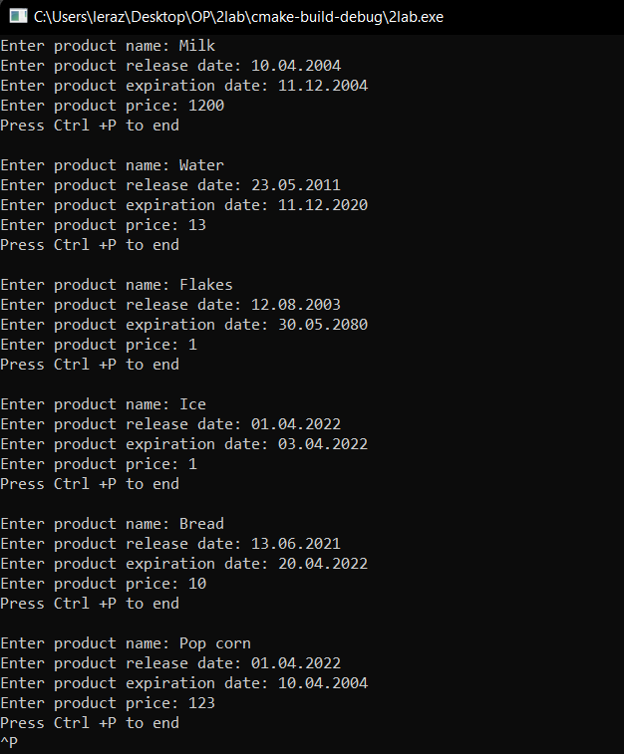

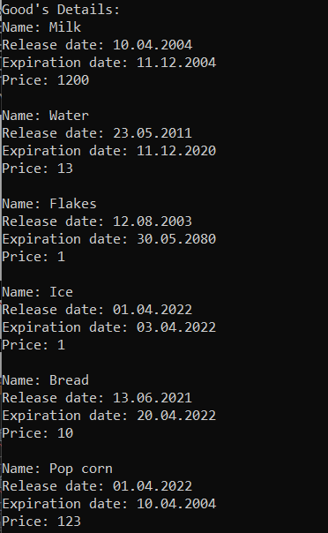



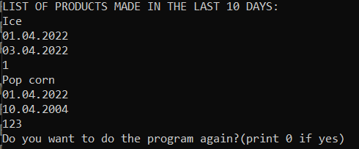

**Python:**

**main:**

import funcs  
  
funcs.make_product_list("product_list_py.dat") # make first file with product list  
funcs.read_file("product_list_py.dat") # to read first file  
print("Finding products")  
# find products to the rule (10% of the time it can be used)  
funcs.transfer_data_expiration("product_list_py.dat", "almost_expired_py.dat")  
print("NEW FILE:")  
# making new file with these products  
funcs.read_file("almost_expired_py.dat")  
# products that have less than 10 days  
funcs.info_ten_days("product_list_py.dat")  
funcs.dopys() # do you want to re-run the file

**funcs:**

import pickle as pk  
from datetime import date, datetime, timedelta  
  
  
def make_product_list(filename):  
 goods_amount = int(input("How much products do you want to add?"))  
 product = []  
 product_info = []  
 for i in range(goods_amount):  
 name = input("Name: ")  
 release_date = input("Release date: ")  
 expirat_date = input("Expiration date: ")  
 price = input("Price: ")  
 product = [name, release_date, expirat_date, price]  
 product_info.append(product)  
 file = open(filename, 'wb')  
 pk.dump(product_info, file)  
 file.close()  
  
  
def read_file(filename):  
 print("The file " + filename)  
 f = open(filename, 'rb')  
 products_data = pk.load(f)  
 f.close  
 for product in products_data:  
 print("Name: " + str(product[0]))  
 print("Release date: " + str(product[1]))  
 print("Expiration date: " + str(product[2]))  
 print("Price: " + str(product[3]))  
  
  
def transfer_data_expiration(from_file, to_file):  
 d1 = datetime.today()  
 print("Today is :" + str(d1))  
 f = open(from_file, 'rb')  
 products_data = pk.load(f)  
 f.close  
 suitable_prod = []  
 suitable_prod_info = []  
 for product in products_data:  
 release = product[1]  
 expire = product[2]  
 dt_start = datetime.strptime(release, '%d.%m.%Y')  
 dt_end = datetime.strptime(expire, '%d.%m.%Y')  
 allowed_time = dt_end - dt_start  
 if d1 > dt_end:  
 substr = d1 - dt_end  
 else:  
 substr = dt_end - d1  
 if allowed_time / 10 > substr:  
 print(product[0] + " fits " + str(allowed_time / 10) + " - " + str(substr))  
 suitable_prod = [product[0], product[1], product[2], product[3]]  
 suitable_prod_info.append(suitable_prod)  
 file = open(to_file, 'wb')  
 pk.dump(suitable_prod_info, file)  
 file.close()  
  
  
def info_ten_days(filename):  
 print("Products made in the last 10 days: ")  
 f = open(filename, 'rb')  
 products_data = pk.load(f)  
 f.close  
 d1 = datetime.today()  
 for product in products_data:  
 release = product[1]  
 dt_start = datetime.strptime(release, '%d.%m.%Y')  
 days_made = d1 - dt_start  
 if days_made <= timedelta(days=10):  
 print("Name: " + str(product[0]))  
 print("Release date: " + str(product[1]))  
 print("Expiration date: " + str(product[2]))  
 print("Price: " + str(product[3]))  
  
def dopys(): #to re-run the program  
 while True:  
 answ = input("Press yes if you want to add and no if you don`t: ")  
 if answ == "yes":  
 make_product_list("product_list_py.dat")  
 read_file("product_list_py.dat")  
 print("Finding products")  
 transfer_data_expiration("product_list_py.dat", "almost_expired_py.dat")  
 print("NEW FILE:")  
 read_file("almost_expired_py.dat")  
 info_ten_days("product_list_py.dat")  
 if answ != "yes":  
 break

**Результат:**

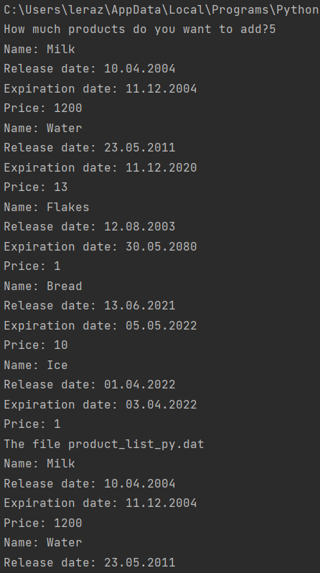

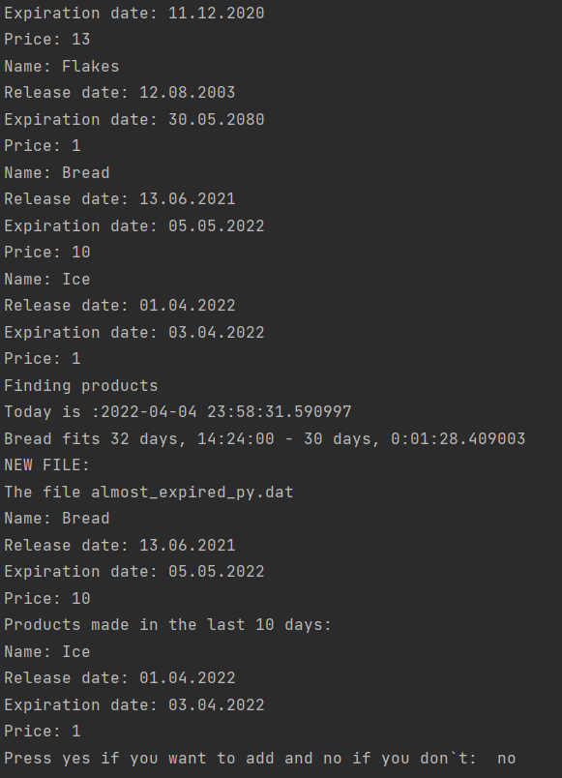

**Висновок**: У цій лабораторній роботі було вивчено особливості створення і обробки бінарних файлів. Була постановлена задача, в якій визначався список продуктів, введений користувачем. У алгоритмі були уточнені обмеження з використанням умов при яких задача буде виконана правильно. За допомоги цієї лабораторної роботи можливо складання списку продуктів, перевірка у яких продуктів завершується термін придатності та які були виготовлені менш ніж 10 днів тому.